SERVICE AGREEMENT

**Between:**

Manuel N Precious & Julia Ngoy   
(Technical Lead and Voter Support Lead)   
Based in Kampala, Uganda

**And**

FAWE Uganda, represented by Natweta & Co. Advocates

**Date:**

**June 26, 2025**

To: Natweta & Co. Advocates

Legal Representatives of FAWE Uganda  
4th Floor Suit 1, Airways House, Plot 8 Colville St, Kampala, Uganda

# **Subject: Technical and Voter Support Services for FAWE Uganda’s Online Board Election**

Dear Team at Natweta & Co. Advocates,

Thank you for the opportunity to support FAWE Uganda with its upcoming online board election.

This agreement outlines the technical and voter support services we will provide, the investment required, and the terms under which this service will be delivered.

Warm regards,

Manuel N Precious – Technical Lead  
Phone: 0784002324

Email: manuel@devmanuel.com

Julia Ngoy – Voter Support Lead  
Phone: 0778298104

Email: juliangoy2021@gmail.com

**1. Purpose of Agreement**

This agreement sets out the terms under which Manuel N Precious and Julia Ngoy will provide technical and voter support services for FAWE Uganda’s upcoming online board election, using the Election Buddy platform.

Our goal is to ensure that the election is conducted securely, inclusively, and without disruption.

**2. Scope of Work**

|  |  |
| --- | --- |
| Role | Key Responsibilities |
| Manuel N Precious (Technical Lead) | - Set up and configure Election Buddy account  - Upload list of 115 voters  - Configure ballots based on FAWE rules  - Run test elections  - Monitor system during live voting  - Export final results  - Provide post-election summary report |
| Julia Ngoy (Voter Support Lead) | - Send pre-election communications via email/SMS  - Conduct short training sessions  - Offer real-time support during voting  - Assist with login issues and browser problems  - Serve as a trusted contact point for female voters |

**3. Investment / Fee Schedule**

Total investment: UGX 1,500,000 (One Million Five Hundred Thousand Shillings)  
This covers full support from setup through to final reporting.

Please note: This amount does not include VAT or any other applicable taxes. If required, these will be added at the time of invoicing.

**4. Payment Terms**

* First Payment (50%) : UGX 750,000 due upon signing of this agreement
* Second Payment (50%) : UGX 750,000 due before the launch of the live voting period
* Payment methods accepted: Mobile money or Cash payment
* Payment details will be shared upon confirmation of this agreement

**5. Estimated Timeline**

|  |  |
| --- | --- |
| Phase | Estimated Time |
| Initial planning | 3–5 hours |
| Voter list & ballot setup | 5–7 hours |
| Communication & training | 4–6 hours |
| Live voting support | 6–8 hours |
| Post-election reporting | 2–3 hours |
| Total | ~25 hours combined |

Work will be scheduled around FAWE’s preferred timeline to minimize disruption.

**6. Changes to Scope**

Any changes to the original scope of work will be discussed and agreed upon in writing before implementation. Adjustments may affect timelines or fees.

**7. Cancellation Policy**

Either party may cancel this agreement in writing:

* If cancelled by FAWE Uganda, payment will still be made for work completed up to the date of cancellation.
* If cancelled by us, FAWE Uganda will receive all completed deliverables up to the point of cancellation.

**8. Confidentiality**

All information shared between the parties during this engagement will remain strictly confidential and will not be disclosed to third parties without prior consent.

**9. Ownership of Deliverables**

All materials created during this engagement (including election setup, voter lists, results, reports, and communications) are the property of FAWE Uganda. We retain no rights to reuse or share this material without permission.

**10. Acceptance**

By signing below, both parties agree to the terms outlined in this agreement.

**For Service Providers:**

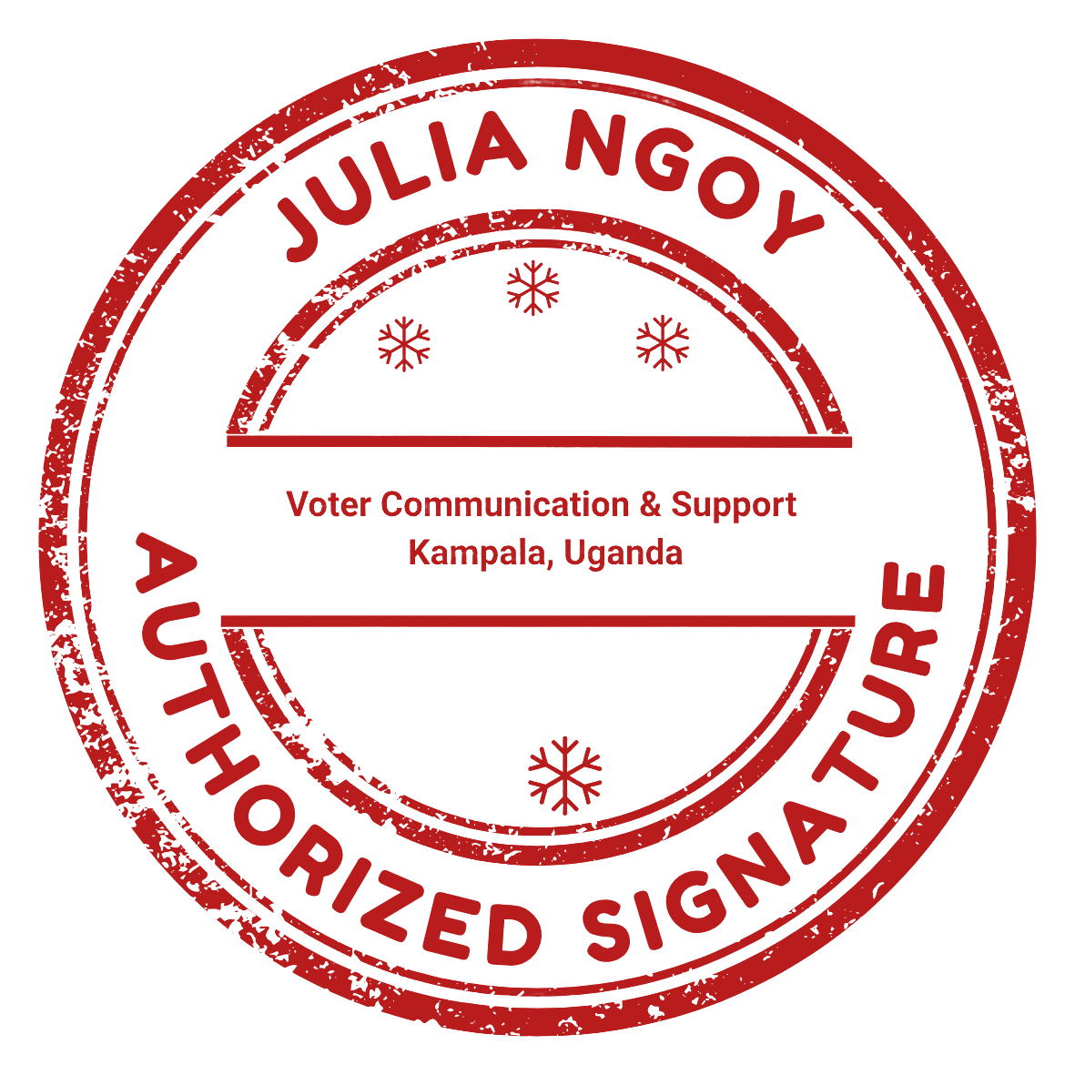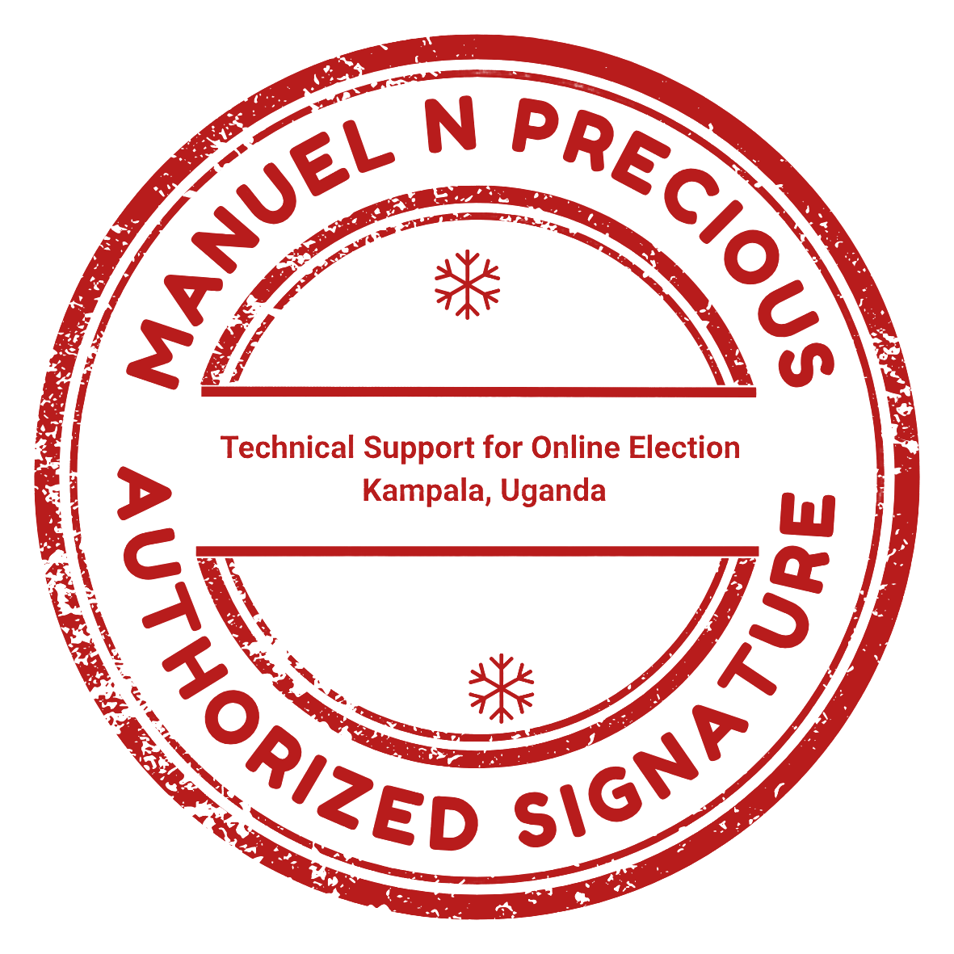

Name: ___________________________  
Signature: _______________________  
Date: ___________________________

Name: ___________________________  
Signature: _______________________  
Date: ___________________________

**For FAWE Uganda (represented by Natweta & Co. Advocates):**

Name: ___________________________  
Position: ________________________  
Signature: _______________________  
Date: ___________________________

**Contact Information**

Manuel N Precious – Technical Lead  
Phone: 0784002324

Email: manuel@devmanuel.com

Julia Ngoy – Voter Support Lead  
Phone: 0778298104

Email: juliangoy2021@gmail.com